COURSE: CLOUD AND NETWORK SECURITY _C1-2024
STUDENT NAME: LENNIE NTHIGA
STUDENT NO: cs-cns07-24170
OCTOMBER 25,2024

WEEK 7 ASSIGNMENT 1
Cloud Goat IAM Privilege Escalation by Rollback Scenario

Contents
Introduction 3
Step 1 3
Installing aws cli 3
Step 2 4
installing cloud Goat 4
Step 3 5
Understanding AWS IAM 5
Step 4 6
Step 5 6
Getting the policy name and policy arn 6
Step 6 7
Getting the list of the policy versions 7
Step 7 8
Version descriptions 8
Step 8 11
Escalating privileges 11
CONCLUSION 12

Introduction
In the activity we would be using cloud goat scenarios for aws cloud that Is "iam_privesc_by_rollback" for escalating privileges and understanding the structure of what permissions/privileges are already set

Step 1

Installing aws cli
- Having an aws account that has access
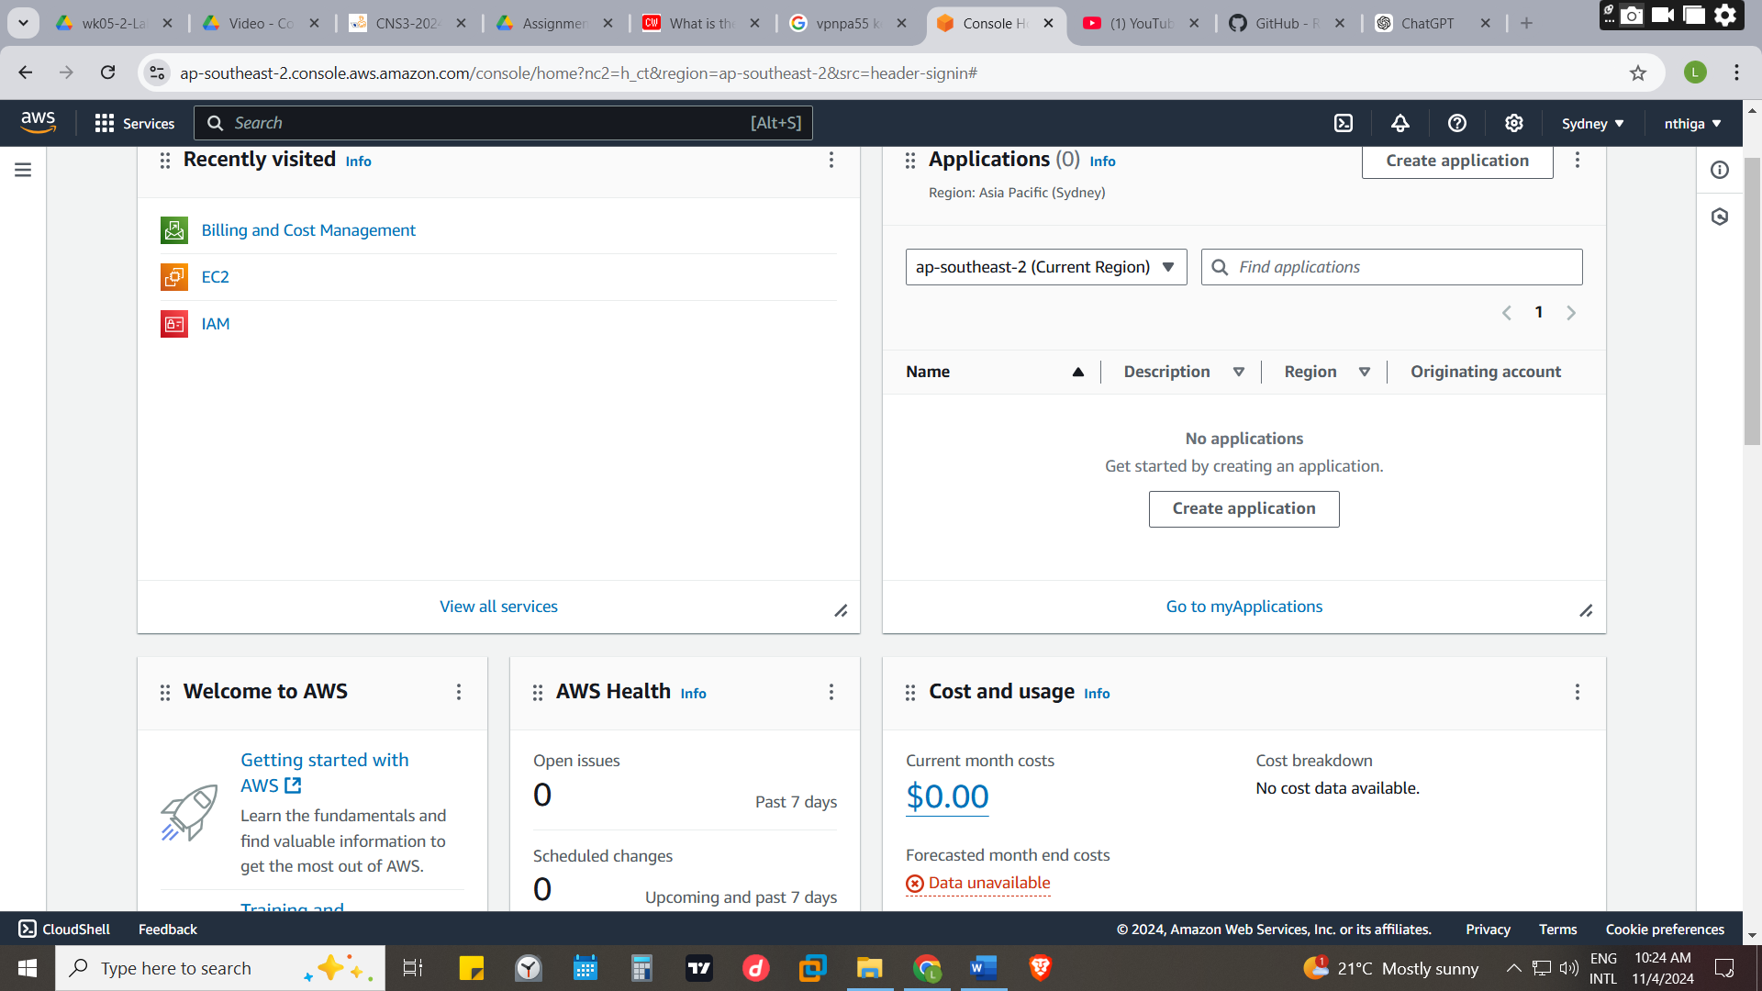
- Installing AWS cli and configuring the profile name
Running
curl "https://awscli.amazonaws.com/awscli-exe-linux-x86_64.zip" -o "awscliv2.zip"
unzip awscliv2.zip
sudo ./aws/install

for profile name and adding the access keys and secret keys when prompted

aws configure --profile tril1profile

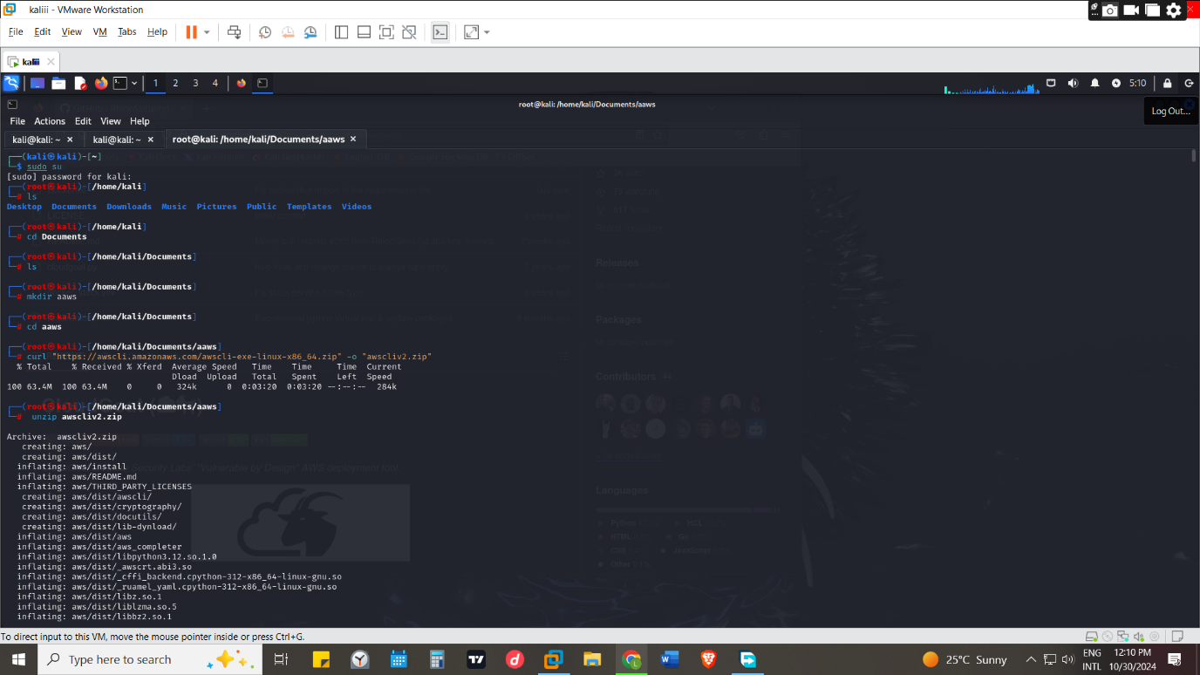

Step 2

installing cloud Goat
- Installing cloud goat in terminal by running
https://github.com/RhinoSecurityLabs/cloudgoat
git clone https://github.com/RhinoSecurityLabs/cloudgoat.git
cd cloudgoat
python3 -m venv .venv
source .venv/bin/activate
pip3 install -r ./requirements.txt
chmod +x cloudgoat.py
- Installing terraforms by running commands from
https://docs.aws.amazon.com/cli/latest/userguide/getting-started-install.html
this version would be older because in kali terraform hashicorp does not support the kali rolling repository thus have to change it from the hashicorp. List by running echo "deb [signed-by=/usr/share/keyrings/hashicorp-archive-keyring.gpg] https://apt.releases.hashicorp.com bookworm main" | sudo tee /etc/apt/sources.list.d/hashicorp.list
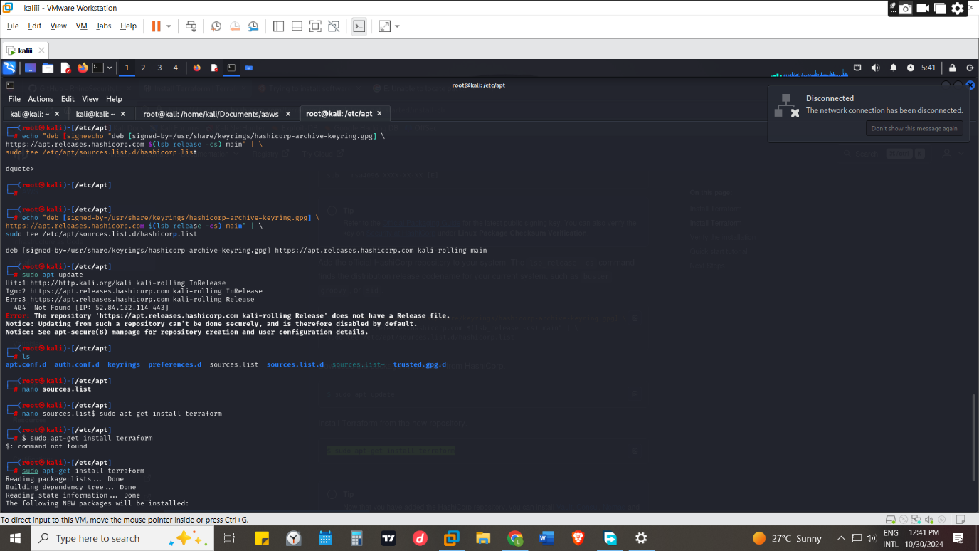

Step 3

Understanding AWS IAM
- IAM is identity and access management are the infrastructure that provides the foundation for access control based on identities within AWS
- The administrator can write policies that define trust policies to control which principals can assume a role, in addition to identity-based policies that specify the actions and resources a user or role can access.
- IAM can be related to when one authenticates and authorizes access to AWS resources the polices configured would ensure users and applications have appropriate level of permissions to perform their required tasks
- IAM can be differed by the type of functions you’re carrying that is
Service user- the person who would be using the computers resources to carry out their jobs they don’t need to have much information on the workings of AWS thus can be given credentials to access the resources their permitted to access
Service administrator -the personal who has the highest privileges who determine which IAM features and resources your service users should access
IAM administrators- they manage IAM identities and write policies to manage access to IAM.
- IAM user is an identity within your AWS account that has specific permissions for a single person or application. Thus, given temporary credentials however if you have a task that going to go on for long one can be issued with long term credentials such as access keys and passwords
- IAM group is a collection of users .Groups make permissions easier to manage for large sets of users thus you can’t sign in as a group
- Users have permanent long-term credentials, but roles provide temporary credentials
- IAM role -is an identity in AWS that has specific permissions in the AWS account that’s not associated with a specific person
- Situations in which temporary credentials for IAM role is useful
Federated user access- is a user that can access secure AWS resources with use of external identities e.g. third parties or Apis
Temporary IAM user permission is an IAM user or role can assume an IAM role to temporarily take on different permissions for a specific task.
Cross-account access – is an IAM role to allow someone (a trusted principal) in a different account to access resources in your account. However, with some AWS services, you can attach a policy directly to a resource a proxy manner lookalike.
Cross -service access- use features in other AWS services.eg call services
Applications running on Amazon EC2- can use an IAM role to manage temporary credentials for applications that are running on an EC2 instance and making AWS CLI or AWS API requests. To assign an AWS role to an EC2 instance and make it available to all of its applications, you create an instance profile that is attached to the instance. An instance profile contains the role and enables programs that are running on the EC2 instance to get temporary credentials.
- A policy is a document that lists the actions that a user can perform and the resources those actions can affect(permissions)
- Trust policies - A trust policy is a specific type of resource-based policy for IAM roles.
- Identity-based policies (inline and managed) -they define the permissions that the user of the ole is able to perform/or denied and on which resources

Step 4
- We would add the scenario of iam_privesc_by_rollback by running ./cloudgoat.py create iam_privesc_by_rollback inside the cloud goat directory for us to use
- We would run $ ./cloudgoat.py config profile so as to add the AWS profile into cloud goat

Step 5

Getting the policy name and policy arn
One can get to confirm the successful configuration of the AWS a profile by running
aws --profile Raynor sts get-caller-identity
where we would get the user’s name which is (raynor-iam_privesc_by_rollback_cgido54cfuo0vo )that would be used in getting the policy name and policy arn by running
aws iam list-attached-user-policies --user-name raynor-iam_privesc_by_rollback_cgido54cfuo0vo --profile Raynor
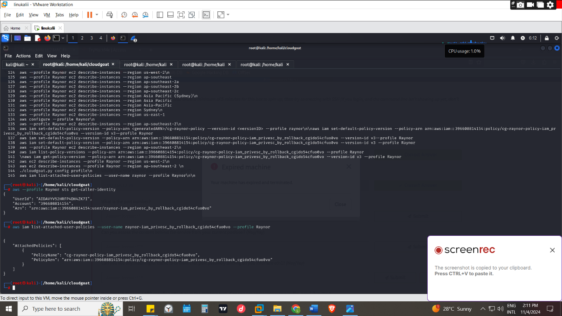

Step 6

Getting the list of the policy versions
We would get the list o the policy versions in that aws account/cloudgoat scenario by running
aws iam list-policy-versions --policy-arn arn:aws:iam::396608814154:policy/cg-raynor-policy-iam_privesc_by_rollback_cgido54cfuo0vo --profile Raynor
in which we would get the list of all versions of the policy
LIST of versions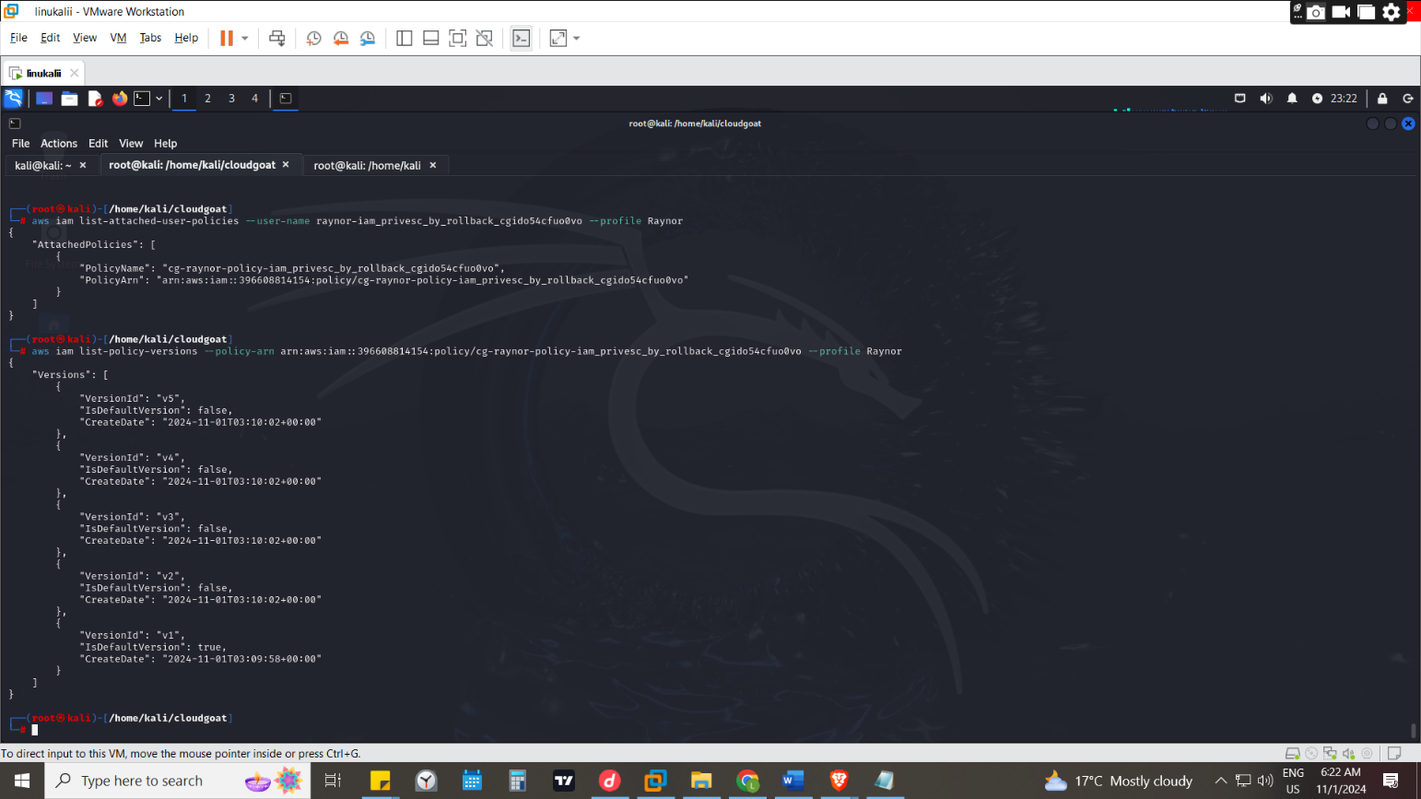

Step 7

Version descriptions
To view each version description by running aws iam get-policy-version --policy-arn <generatedARN>/cg-raynor-policy --version-id <versionID> --profile raynor
E.g. below is v1
Which it had permissions for actions in getting listing and allows the user to set a specified version of a managed policy as the default from all resources 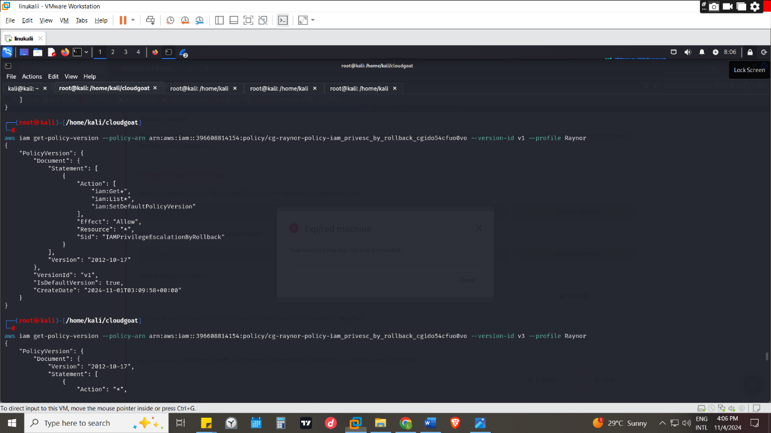
E.g. below if the version 2 & 3 description which gives a view of the
V3 Was Given permissions which is indicated on the effect as allow for accessing resources indicated by the *and carrying out actions indicated by the * in the account
V2 was given permissions also but in the actions its privileged to only get the resources and the resources that it can access is granted all however it was a limited to time by being given a duration of from DateGreaterThan": {
"aws:CurrentTime": "2017-07-01T00:00:00Z"
},
to "DateLessThan": {
"aws:CurrentTime": "2017-12-31T23:59:59Z"
After that date the privileged would end and won’t be used
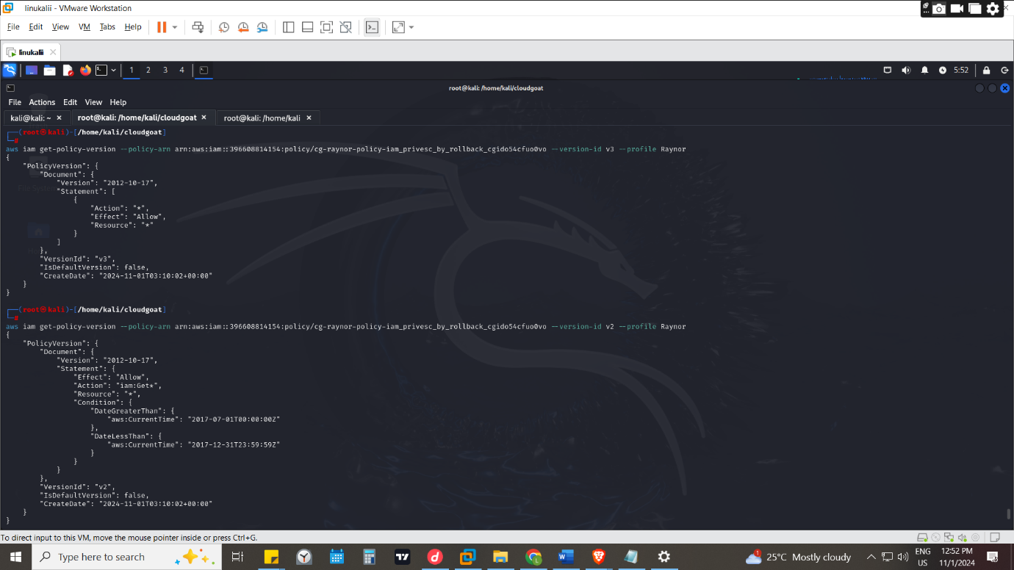
Bellow is for v4 and 5
V4 is whereby it denies all actions from IP addresses not specified in the NotIpAddress condition. That is "192.0.2.0/24", "203.0.113.0/24" in this case
V5 is whereby the user has permission to all resources and specific actions which are the "s3:ListBucket", "s3:GetObject", "s3:ListAllMyBuckets" which are
s3:ListBucket- Allows listing the objects in a bucket.
s3:GetObject- Allows retrieving objects from a bucket
s3:ListAllMyBuckets- Allows listing all buckets owned by the user.
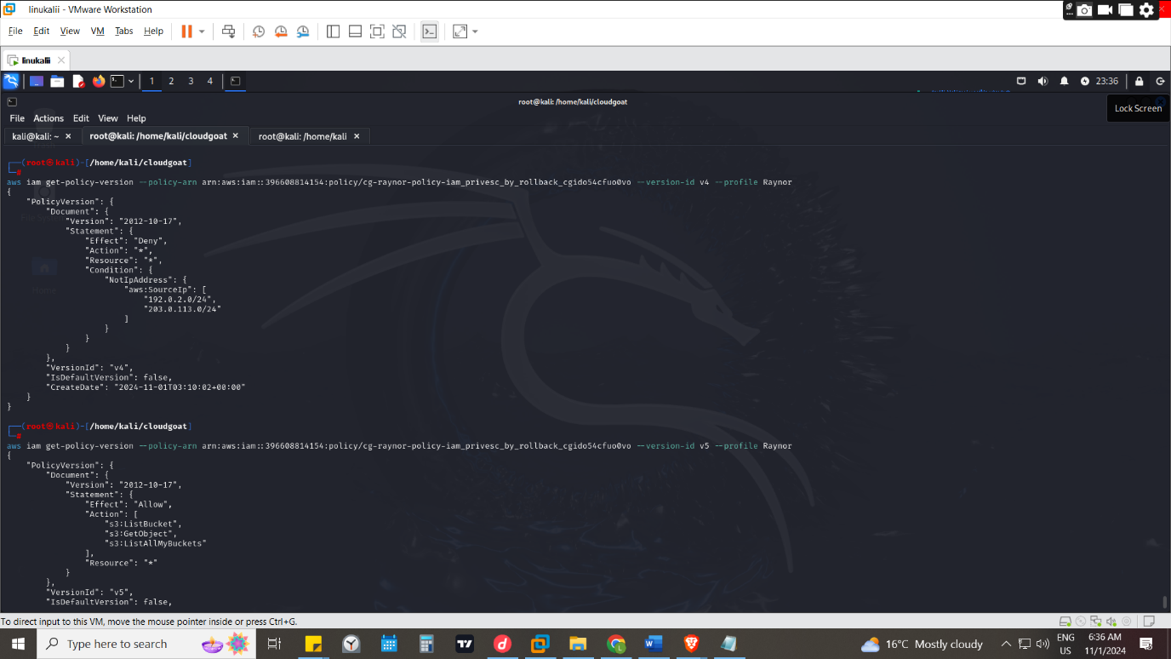

Step 8

Escalating privileges
Changing the default version
We discovered that v3 had the most permissions but it had the "IsDefaultVersion": false, flag meaning it wasn’t the default version that would be used in AWS cli when running thus we have to make it the default version so as to ain those privileges it encores
By running
aws iam get-policy-version --policy-arn arn:aws:iam::396608814154:policy/cg-raynor-policy-iam_privesc_by_rollback_cgido54cfuo0vo --version-id v3 --profile Raynor
as shown which would turn to true
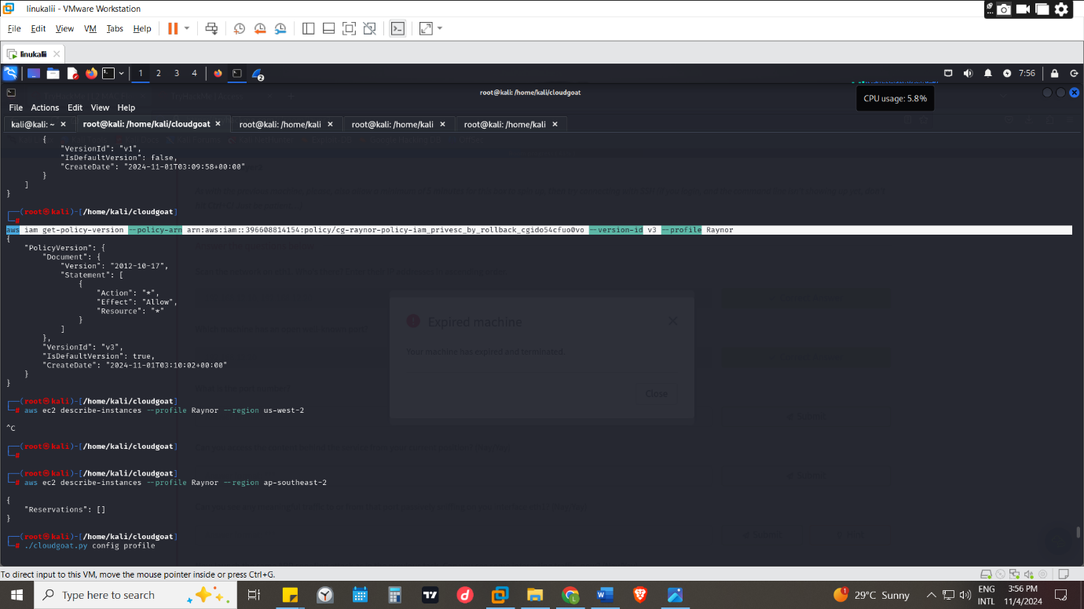
Before the version being changed it was v1 that was the default version to be used
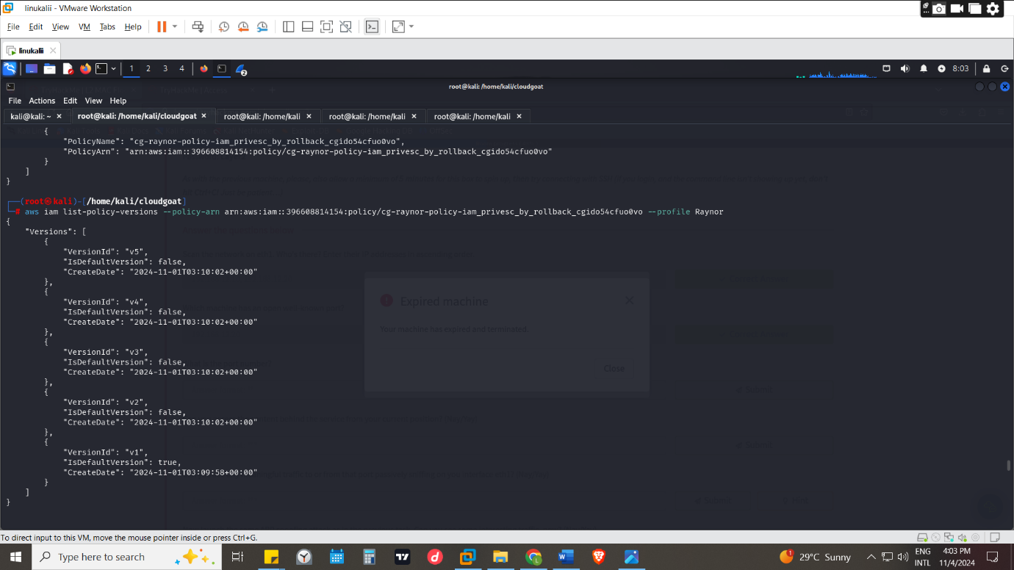

CONCLUSION
Since the default version to be used in AWS cli was v1 which had permissions is changing the default versions we used that version to change the version to v3 which had all action permission for all resources compared to v1 which had specified privileged which were “iam:Get*", "iam:List*" ,"iam:SetDefaultPolicyVersion only

